API Project Write Up by Alexis Montes

API’s Used:

OpenWeatherMap: <https://openweathermap.org/>

Endpoint: https://[api.openweathermap.org/data/2.5/](https://samples.openweathermap.org/data/2.5/)

Documentation: https://openweathermap.org/appid#use

GIPHY: <https://developers.giphy.com/>

Endpoint: https://api.giphy.com/v1/gifs/search

Documentation: <https://developers.giphy.com/docs/api#quick-start-guide>

Authentication Process:

Both API”s require the use of a unique api key that is generated when creating a developer account, that key is sent in the parameters of the query, along with any other required information from the user or the previous API request. Similarly both API’s both return a JSON response with the relevant information. Though the openWeatherMap API’s JSON object only contains basic information, while the GIPHY API returns an array of “GIF Objects” that contains its own sets of properties, that is outlined in their online documentation.

Sequence Diagram:

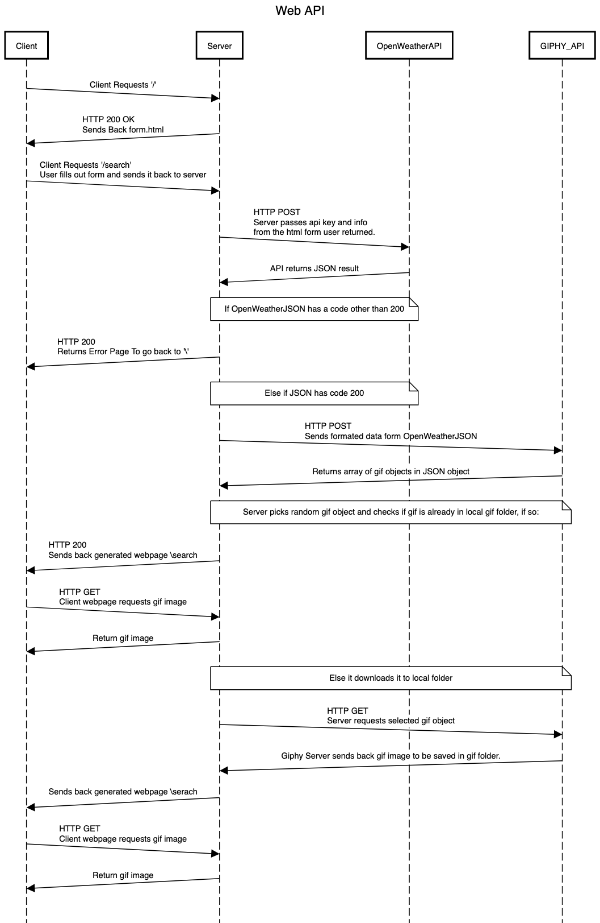

Data structures used

**OpenWeatherMap**: In this api the JSON response we do receive we only have the one JSON object that lists data in common variable format.

**GIPHY**: For this api it returns an array of “GIF objects” each of which contains other types of objects though most are not relevant, we only need the url variable and basic info about the gif.

**Server**: Basically all we will use are JSON objects such that one will hold our api keys and we could potentially use another to hold data that we want to save data that is not expired.

What can we cache:

OpenWeatherMap: From this api we can save the weather for an area and save that info locally so that we can just look up locally the relevant info. Though we want to replace this data when it expires probably within an hour of first requesting the data.

GIPHY: From this api we can save the search results from the api and save the array for further use instead of requesting this over and over.

Server: We can save any gifs that have been requested and downloaded to the local gif folder.

Problems, technical limits

Even with all the potential data we can cache there are some issues with saving the data. For the weather data we can save it but we will typically want the latest data available for what the current weather is. For the giphy data although we can save a large enough array for each weather type and keep using them for a certain time but the results change based on trending results and sometime we get gifs that have nothing to do with weather. So we want to generate a new json everytime to get the best results possible. So in the end the only thing that we cached was just the gif images.